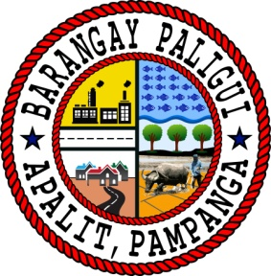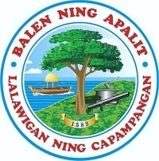Republic of the Philippines

Region III

Province of Pampanga

Municipality of Apalit

**BARANGAY PALIGUI**

*Office of the Sangguniang Kabataan*

**INTER-BARKADA BASKETBALL TOURNAMENT AWARDING**

**June 23, 2024 (Sunday)**

**TROPHIES**

**Seniord Division**

CHAMPION – Friends Forever

1st Runner Up – Alexis Fighter

2nd Runner Up – Perpetual

**Junior Division**

CHAMPION – Archers

1st Runner Up – Well Played

2nd Runner Up – Badeo

**Midget Division**

CHAMPION – Archers

1st Runner Up – Camella Ballers

2nd Runner Up – Badeo

**Finals MVP Awardee**

Senior Division – Vince Dizon

Junior Division – Lance Lopez

Midget Division – Dwaine Pineda

**Season MVP Awardee**

Senior Division – Mark Renz Ramos

Junior Division – Harold Alfonso

Midget Division – Dwaine Pineda

**MEDALS**

**Team Paligui’s PrideRecognition**

**Head Coach:** Councilor Elias Mendoza

**Asst. Coaches:** Kag. Florentino Ramos

Kag. Edilberto Dizon

Emil Alfonso

Ian Jaspher Villarico

**Players:** Edmar Dizon

Tom Aldrin Villarico

Sam JB Bernardo

Leonel Dale Fabian

Vince Padilla

John Patrick Landig

Lei Reizen Roxas

Liam Baylon

Adrian Louie Pingol

Kirby Gozum

Andrei De Leon

John Jaster Fabian

Kher Jonas Rotoni

Leinard Bacani

Stephen John Jardinico

**MYTHICAL 5**

**Midget Division**

1. Prince Lopez
2. Adams Adrian Alfonso
3. Dwaine Pineda
4. Tyron Manansala
5. Clyde Pineda

**Junior Division**

1. Harold Alfonso
2. Tom Aldrin Villarico
3. Sam Bernardo
4. Lance Lopez
5. Adrian Mendoza

**Seniord Division**

1. Mart Jay Prado
2. John Jester Alfonso
3. Mark Renz Ramos
4. Carlo Alfonso
5. John M. Alfonso